SPRINT-4

|  |  |
| --- | --- |
| Date | 13 November 2022 |
| Team ID | PNT2022TMID31899 |
| Project Name | IOT BASED CROP PROTECTION SYSTEM FOR  AGRICULTURE |

**Procedure :**

STEP 1:

Create an account <http://ai2.appinventor.mit.edu/>using this website. And click create app. Then give your app name it automatically create project. Then design your app using designer mode.

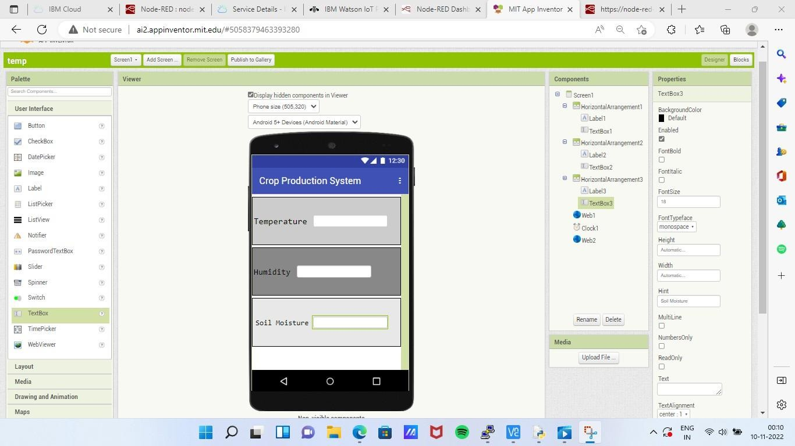

STEP 2:

Go to block mode to connect Node-RED and MIT AI2 app inventor.

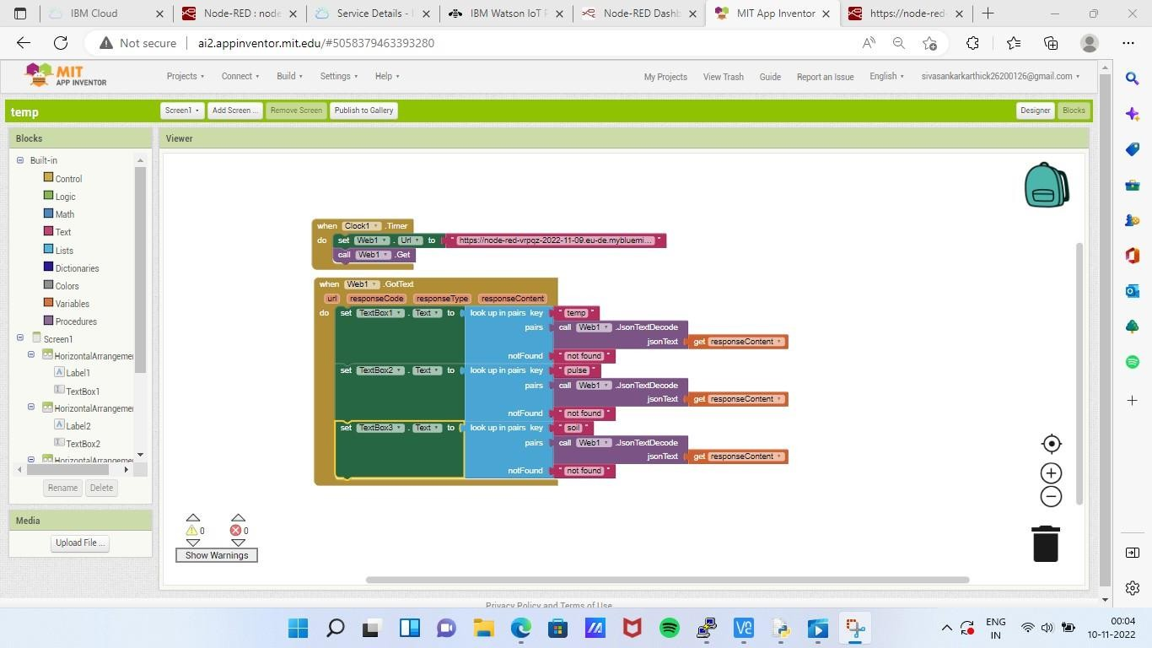

**RESULT:**

This is the final android application using mit ai2 app.you can buil apk and install in your android mobile.

